You are given a **0-indexed** integer array nums, where nums[i] is a digit between 0 and 9 (**inclusive**).

The **triangular sum** of nums is the value of the only element present in nums after the following process terminates:

1. Let nums comprise of n elements. If n == 1, **end** the process. Otherwise, **create** a new **0-indexed** integer array newNums of length n - 1.
2. For each index i, where 0 <= i < n - 1, **assign** the value of newNums[i] as (nums[i] + nums[i+1]) % 10, where % denotes modulo operator.
3. **Replace** the array nums with newNums.
4. **Repeat** the entire process starting from step 1.

Return *the triangular sum of* nums.

**Example 1:**

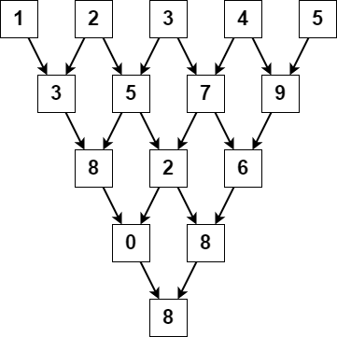

**Input:** nums = [1,2,3,4,5]

**Output:** 8

**Explanation:**

The above diagram depicts the process from which we obtain the triangular sum of the array.

**Example 2:**

**Input:** nums = [5]

**Output:** 5

**Explanation:**

Since there is only one element in nums, the triangular sum is the value of that element itself.

**Constraints:**

* 1 <= nums.length <= 1000
* 0 <= nums[i] <= 9